TASK-01

Implementation of graph search algorithms(Breadth first search and Depth first search)
TASK –1A: Breadth First search Program:
from collections import deque

def bfs (graph, start): visited = set ()
queue = deque([start]) visited. Add(start)

print("BFS Traversal:", end=" ")

while queue:
vertex = queue.popleft() print(vertex, end=" ")

for neighbor in graph[vertex]: if neighbor not in visited:
visited.add(neighbor) queue.append(neighbor)

graph = {
'A': ['B', 'C'],

'B': ['D', 'E'],
'C': ['F'],
'D': [],
'E': [],
'F': []
}

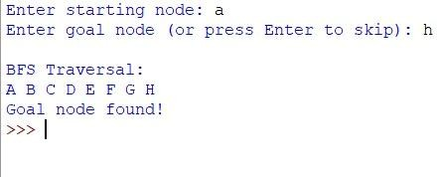
start = 'A' bfs(graph, start) OUTPUT:

TASK-1B : Deapth First search Program:
def dfs(graph, vertex, visited): visited.add(vertex) print(vertex, end=" ")

for neighbor in graph[vertex]: if neighbor not in visited:
dfs(graph, neighbor, visited)

graph = {
'A': ['B', 'C'],
'B': ['D', 'E'],
'C': ['F'],
'D': [],
'E': [],
'F': []
}

visited = set()

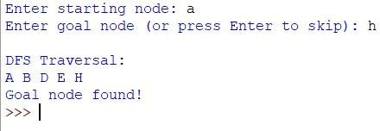
print("DFS Traversal:", end=" ") dfs(graph, 'A', visited) OUTPUT:

